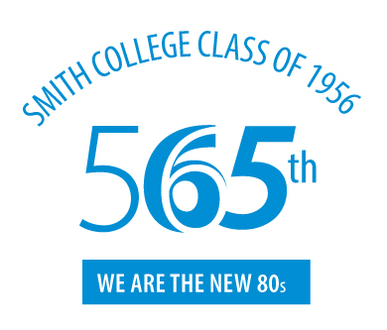

REUNION PROGRAM

Welcome Eldernauts!

Presentation by Rosanne M. Leipzig, MD, PhD
An Insider’s Guide to Aging
Or
You’re 85 – Now what?

Breakout Sessions to Chat

Virtual Sendoffs

